**GANTT CHART**

|  |  |  |
| --- | --- | --- |
| **Start date** | **Days to complete** | **Topic** |
| 2019-03-18 | 2 days | User login page |
| 2019-03-20 | 3 days | Booking |
| 2019-03-23 | 2 days | View booking |
| 2019-03-25 | 2 days | Gallery |
| 2019-03-27 | 2 days | Admin login page |
| 2019-03-29 | 3 days | Updating |
| 2019-04-01 | 3 days | View booked halls |
| 2019-04-04 | 1 days | About us |
| 2019-04-05 | 1 days | Contact us |
| 2019-04-06 | 5 days | Home page |
| 2019-04-11 | 4 days | All links connection and design of webpage |

**DESCRIPTION OF PROJECT**

We have given a project to make a website on Auditorium and Seminar Hall booking systemusing HTML, CSS and JAVASCRIPT.

We are making a website with four group members on the Auditorium and Seminar Hall booking system in which we have divided four modules:

1. HOME PAGE INCLUDING ABOUT US AND CONTACT US
2. ADMIN PAGE
3. USER LOGIN
4. BOOKING AND VIEW BOOKING REQUEST

**HOME PAGE**

We are make a home page for our website where we have gave an option to user to open our website and click on login to log into their account.

We also gave an option to admin to update and delete anything in the website.

Next one is very important in the home page is that we gave a best option to every user to give their suggestion or feedback according to their behaviour towards our website.

**ADMIN PAGE**

Here in this firstly admin login to their ID and then two options are shown to admin:

1. Updating
2. View bookings

In updating, admin tell us the website about new hall details includes:

*Auditorium ID, seats, cost and address*

In view bookings, admin can see the booked halls by user or we can say that admin has the access to view the booked halls of the user.

**USER LOGIN**

If a new user wants to login to our website then he has to create its new account by click on sign in and then he gave his details along with a username and a password.

Then after creating account, user login to their account and start to book the halls according to their needs.

Gallery is also available in every user account to gave a view of seminar halls.

**BOOKING AND VIEW BOOKING REQUEST**

User can book their halls which are available in their account and pay according to their cost.

If a user booked any hall he has the right to view their booking status.

**SEMINAR HALL BOOKING WEBSITE**

**LAYOUT OF OUR HOME PAGE:**

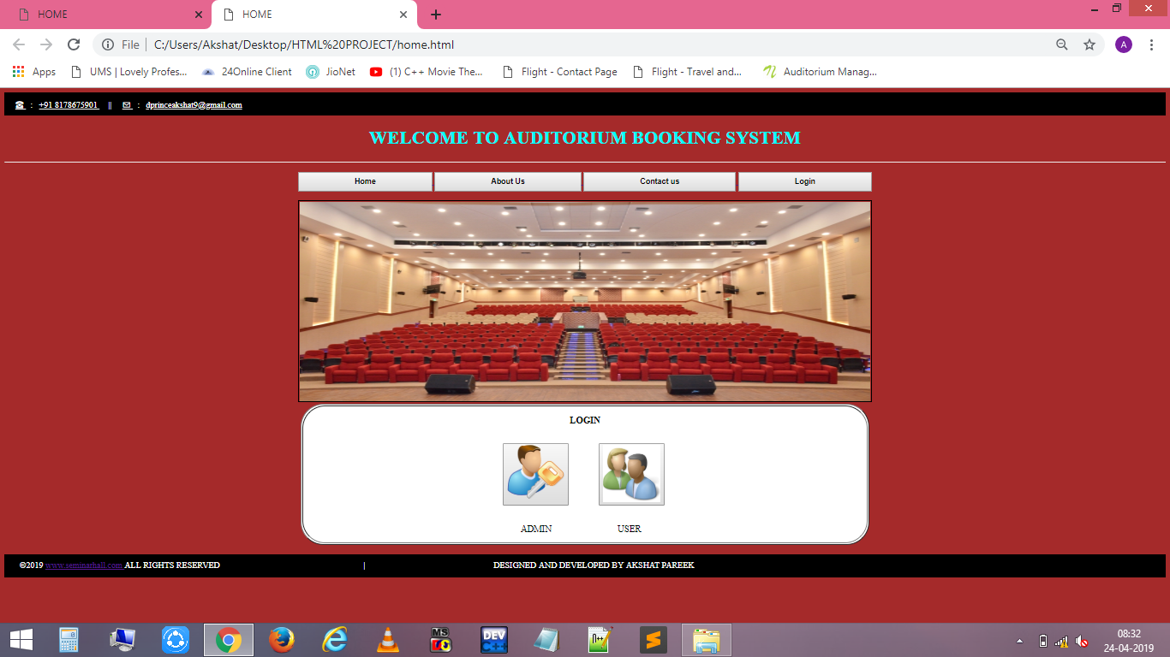

**BENEFITS OF BOOKING ONLINE:**

Best advantage to book any seminar hall is that it saves our time to go that place and see the halls.

We can see different halls at their reasonable prices at one place the need is only of net.

We have more than one choice to choose any one hall which is best to our outfit.

**WHAT WE WILL INCLUDE IN OUR SEMINAR HALL BOOKING WEBSITE**

* HOME PAGE

🡪ABOUT US PAGE

It tell about our page.

🡪 CONTACT US PAGE

It gives the user to give their feedback and suggestion.

* LOGIN PAGE

🡪User login

Inside this new user can create his new account and open their account. And next he booked hall of their choice.

🡪Admin login

Admin has the access key to view and update anything in the website data. He can check the status of user booked halls also.